Clint Scott
CSD 430
Modules 5 & 6
11/16/2025
Note: I also included screenshots of all the webpages for Modules 5 and 6 for your convenience.
- CREATE DATABASE
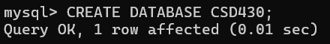
- CREATE USER - ERROR DUE TO USER ALREAD EXISTING FROM PREVIOUS CLASS
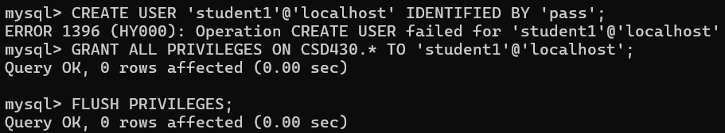
- CHANGING PASSWORD FOR USER STUDENT1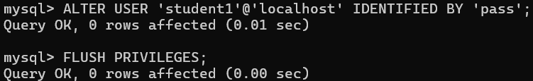
- CREATE TABLE
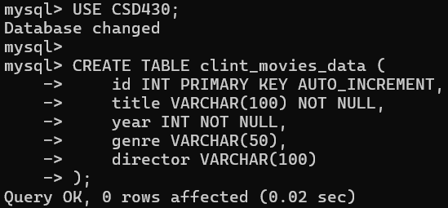
- INSERT RECORDS
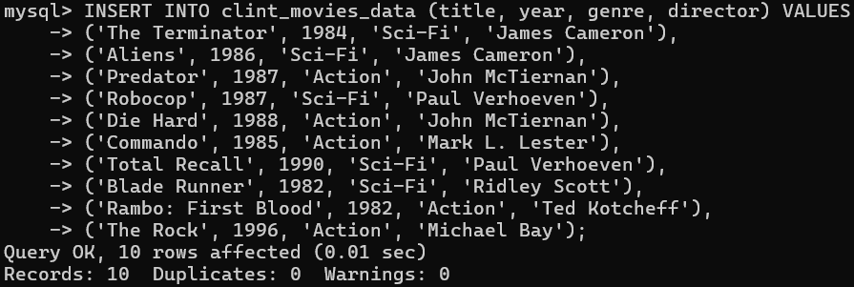
- TABLE RECORDS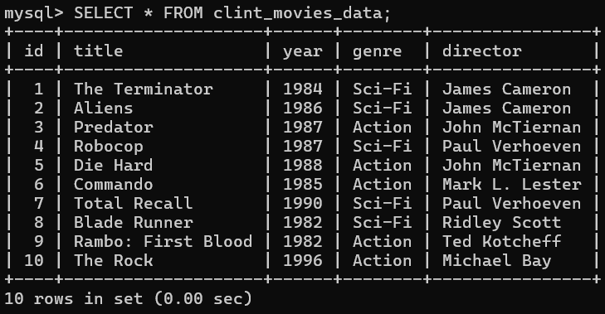
- http://localhost/CSD430_Module56/index.jsp
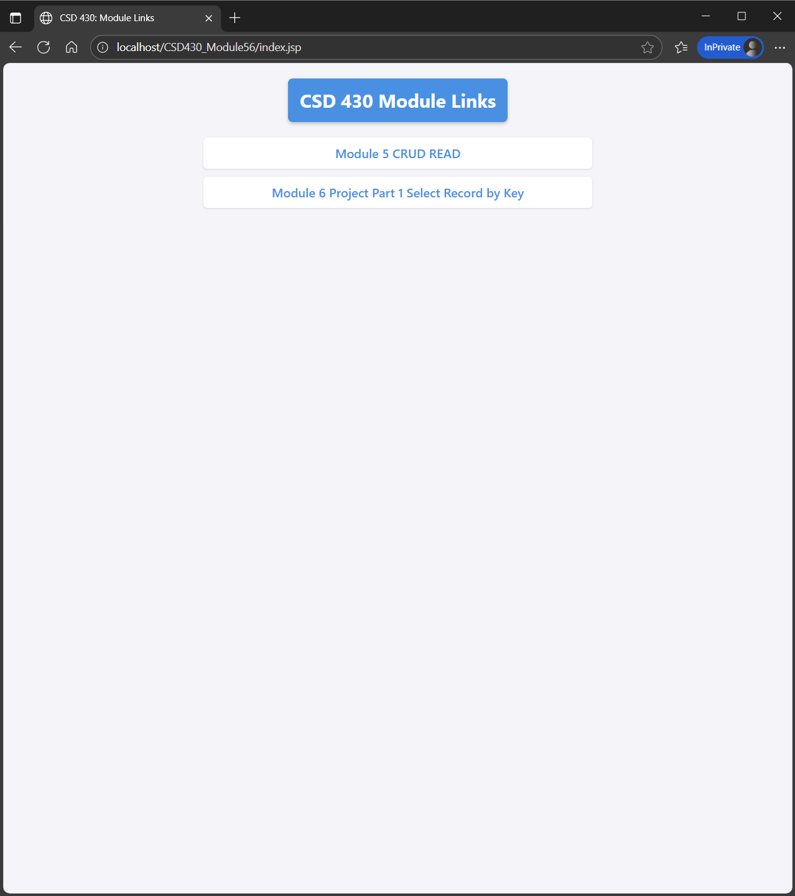
- http://localhost/CSD430_Module56/module5_read.jsp
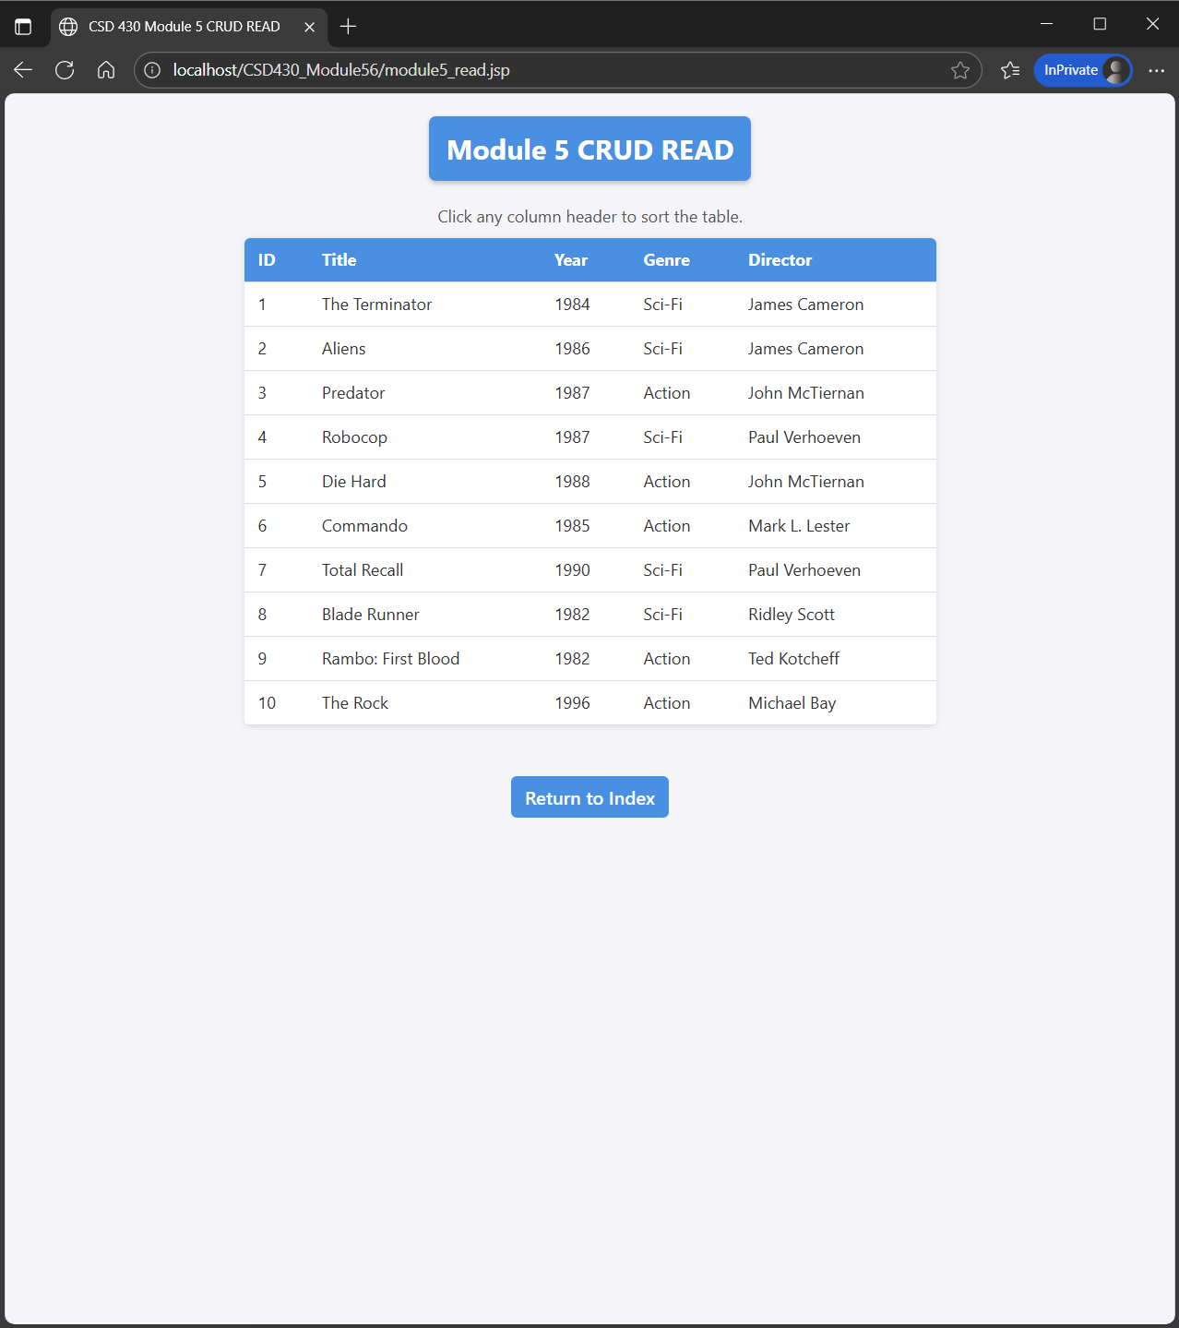
- http://localhost/CSD430_Module56/module6_select.jsp
